labrotary work №5

computer architecture

Ali hosseinabadi

Content

# 1 Objective of the Work

The objective of this laboratory work is to acquire practical skills in using Midnight Commander and to learn the basic instructions of the assembly language: mov and int.

# 2 Task

1. Basics of working with Midnight Commander
2. Structure of a program written in NASM assembly language
3. Including an external file
4. Completing the assignments for self-study

# 3 Theoretical Introduction

Midnight Commander (or simply mc) is a program that allows users to browse directory structures and perform basic file system management operations. Thus, mc functions as a file manager. Midnight Commander makes working with files more convenient and visually understandable.

A program written in the NASM assembly language typically consists of three sections: the program code section (SECTION .text), the initialized data section (known at compile time) (SECTION .data), and the uninitialized data section (which is allocated memory at compile time but assigned values during program execution) (SECTION .bss).

To declare initialized data in the .data section, the directives DB, DW, DD, DQ, and DT are used, which reserve memory and specify which values should be stored in that memory:

* DB (define byte) — defines a variable of 1 byte;
* DW (define word) — defines a variable of 2 bytes (word);
* DD (define double word) — defines a variable of 4 bytes (double word);
* DQ (define quad word) — defines a variable of 8 bytes (quad word);
* DT (define ten bytes) — defines a variable of 10 bytes.

## 3.1 Conducting the Laboratory Work

### 3.1.1 Basics of Working with Midnight Commander

By entering the appropriate command in the terminal (Figure -fig. 1), I open Midnight Commander (Figure -fig. 2).

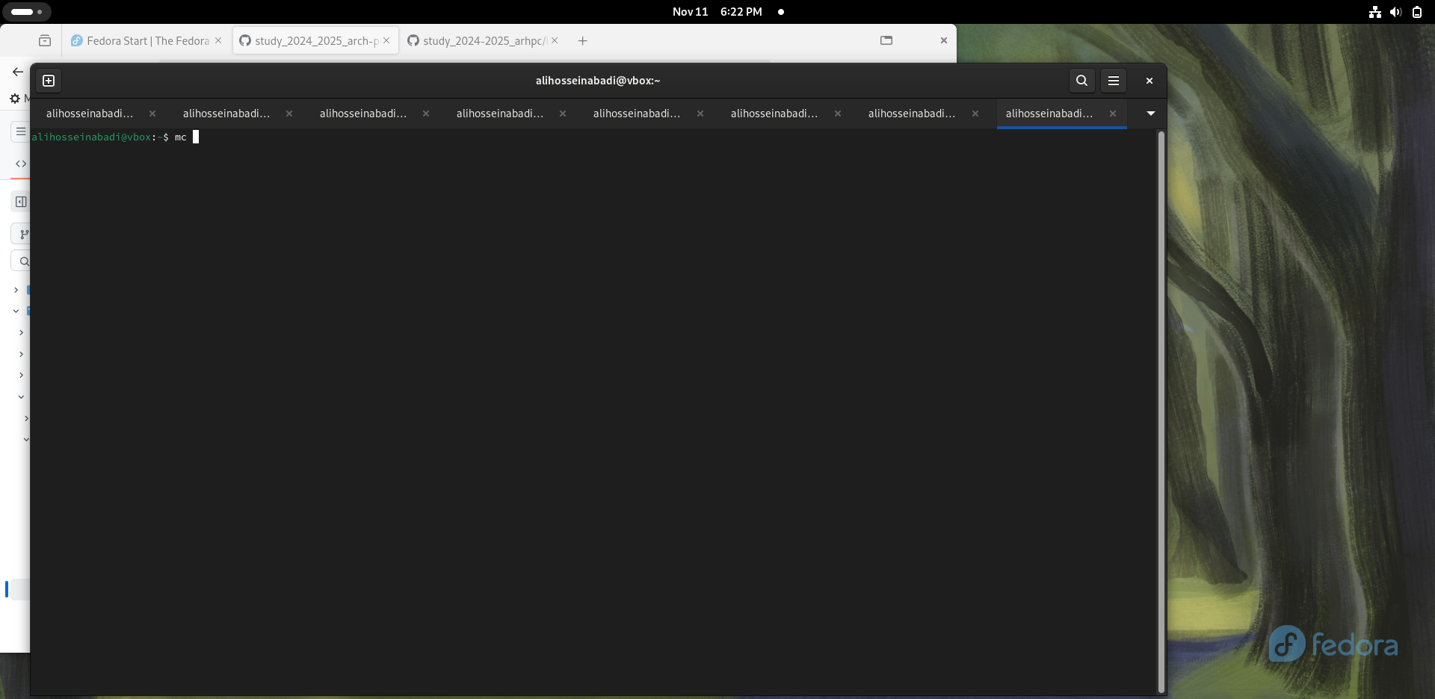

Рис. 1: Opening Midnight Commander

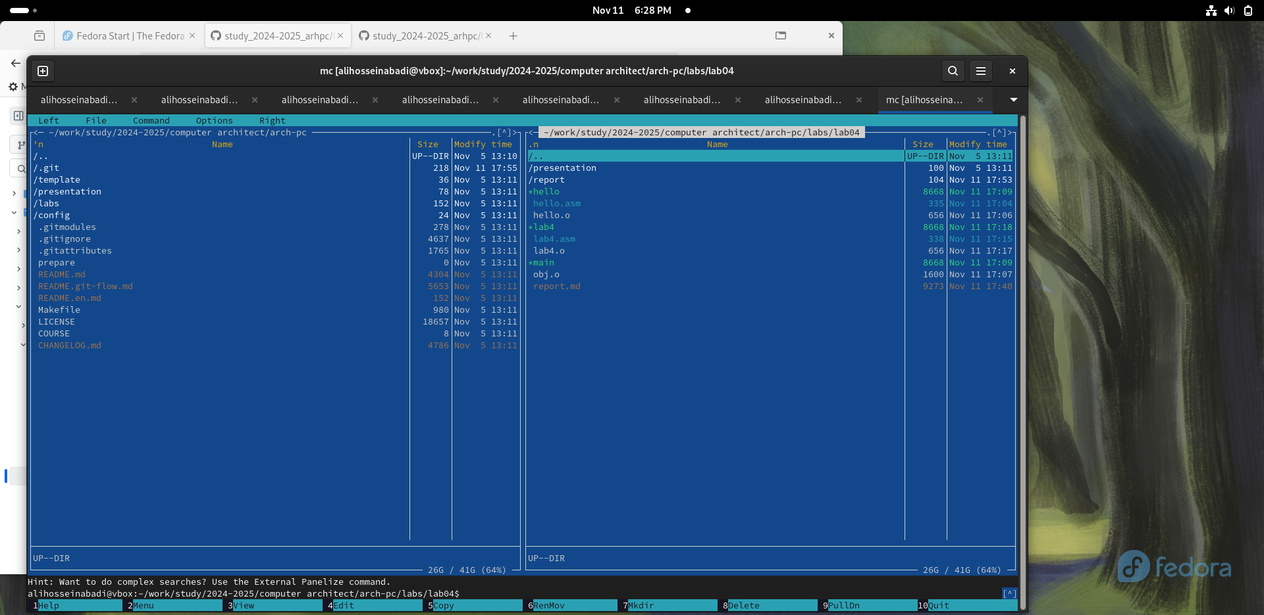

Рис. 2: Midnight Commander Interface

I navigate to the directory created in the previous laboratory work (Figure -fig. 3).

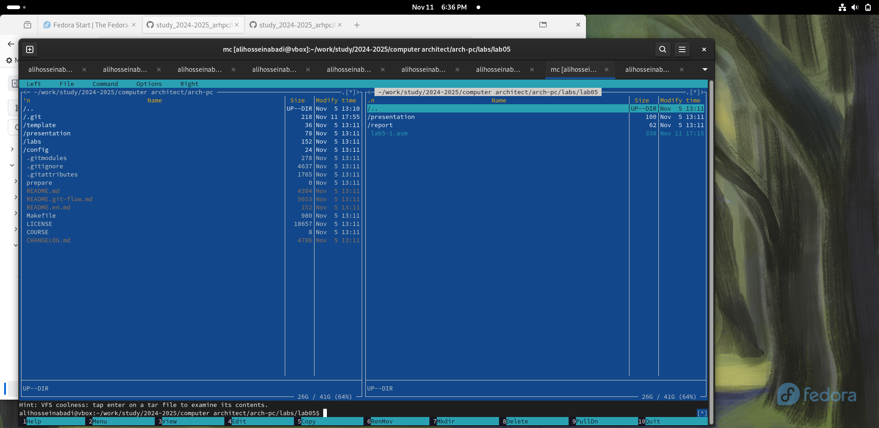

Рис. 3: Opened Directory arch-pc

Using the function key, I create a subdirectory lab05, where I will work (Figure -fig. 4).

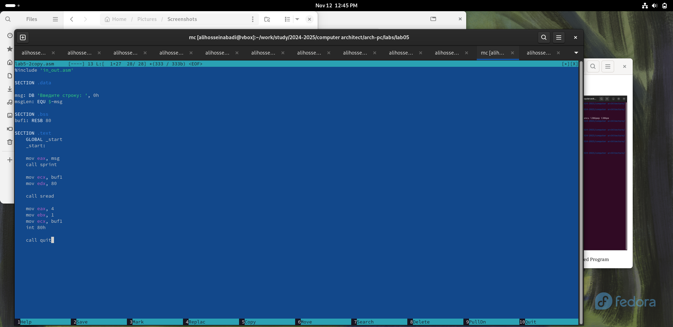

Рис. 4: Creating Working Subdirectory

In the input line, I enter the command touch and create a file (Figure -fig. 5).

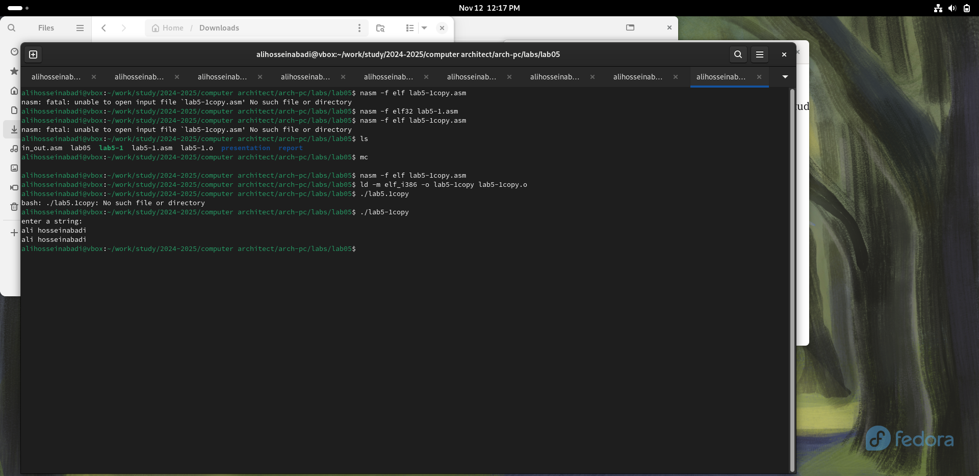

Рис. 5: Creating a File in Midnight Commander

I use F4 to open the newly created file and enter the code from the listing (Figure -fig. 6).

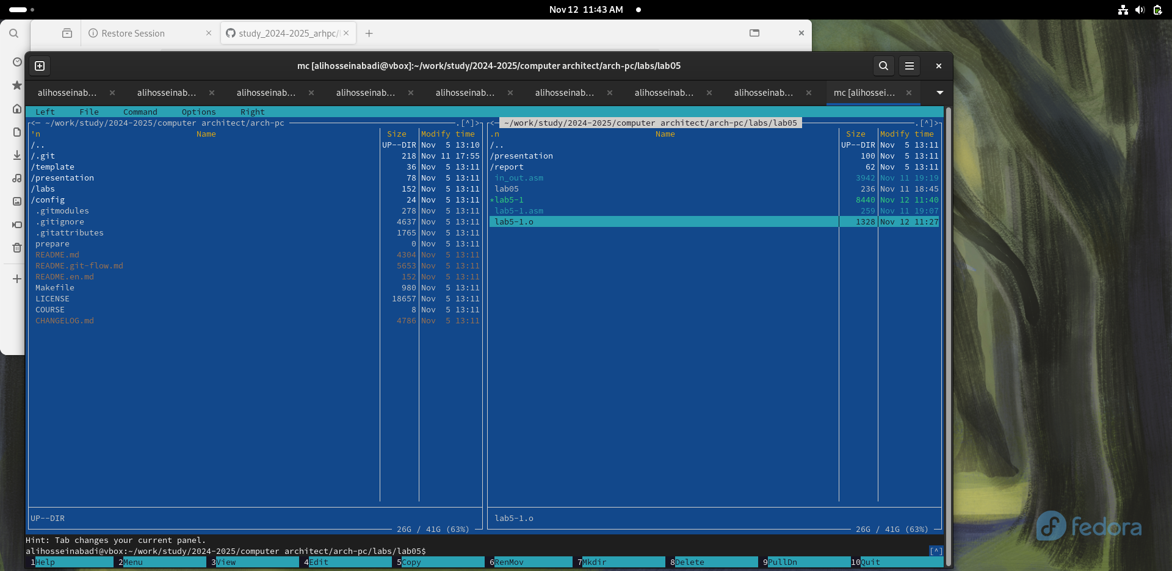

Рис. 6: Editing the File in Midnight Commander

I check the saved changes using the F3 key (Figure -fig. 7).

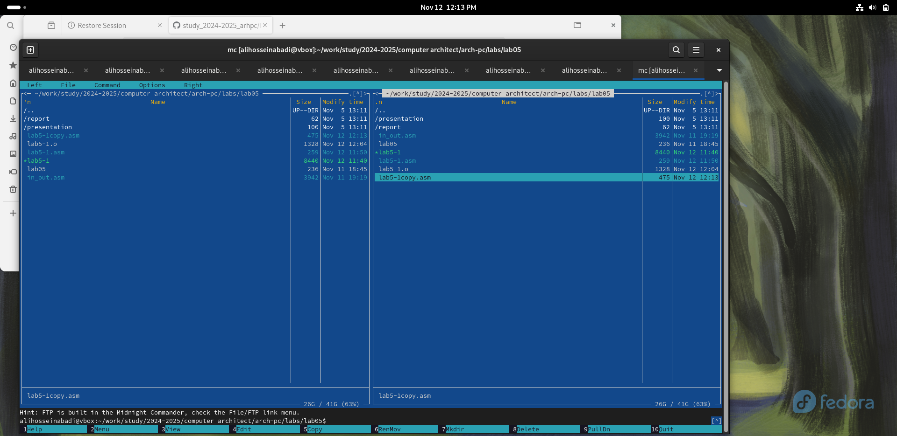

Рис. 7: Checking Saved Changes

I compile and execute the modified file (Figure -fig. 8).

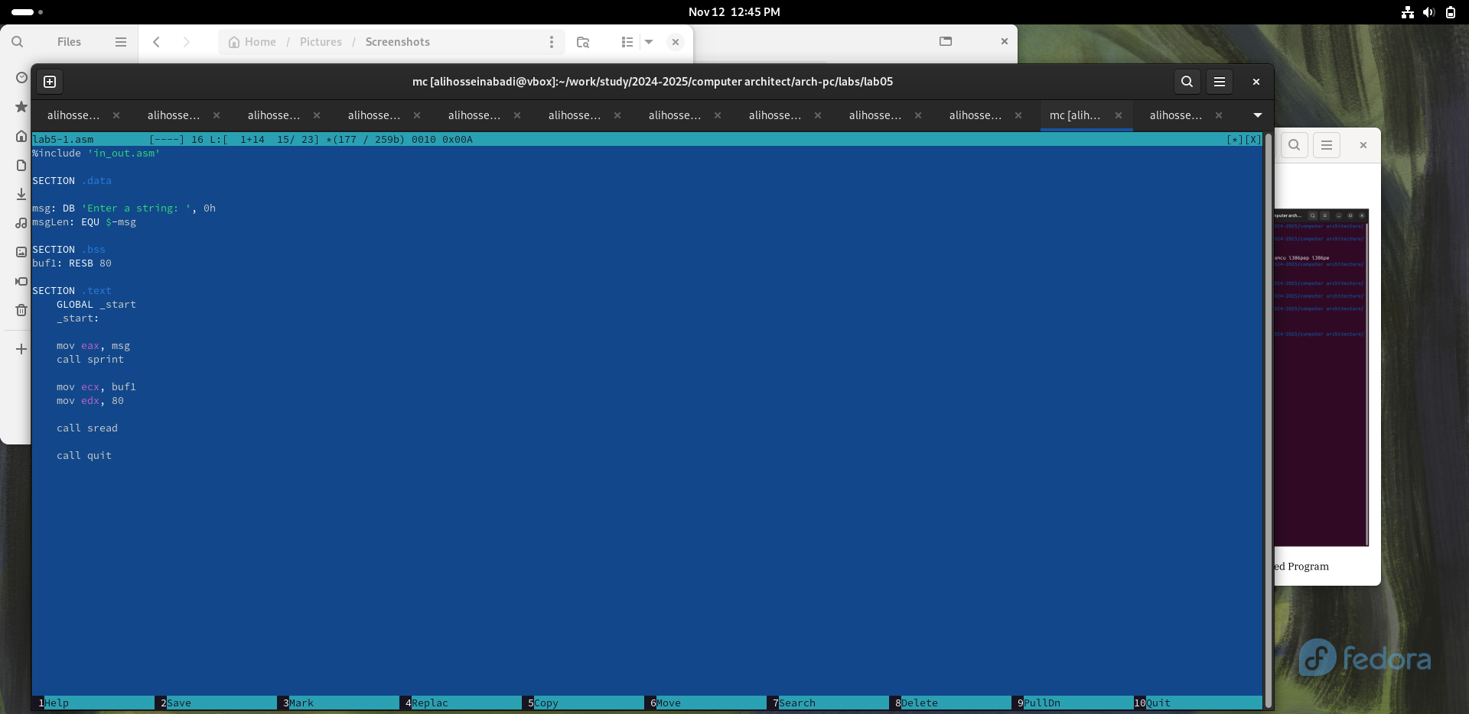

Рис. 8: Running the Modified Program

### 3.1.2 Connecting an External File

I save the file downloaded from TUIS to a shared folder on my computer, then in the virtual machine, I go to the directory of the shared folder, copy the file to the working subdirectory (Figure -fig. 9).

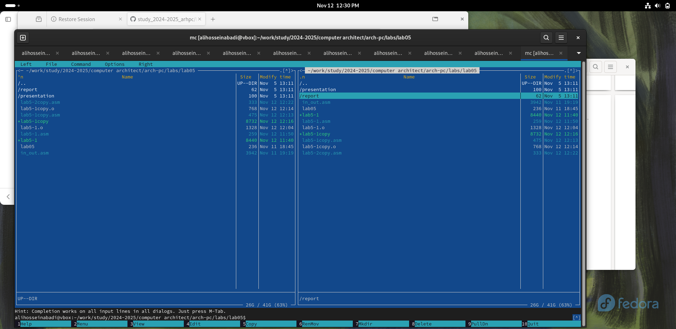

Рис. 9: Copying the File to the Working Directory

I include subroutines from the included file in the copy of the file (Figure -fig. 10).

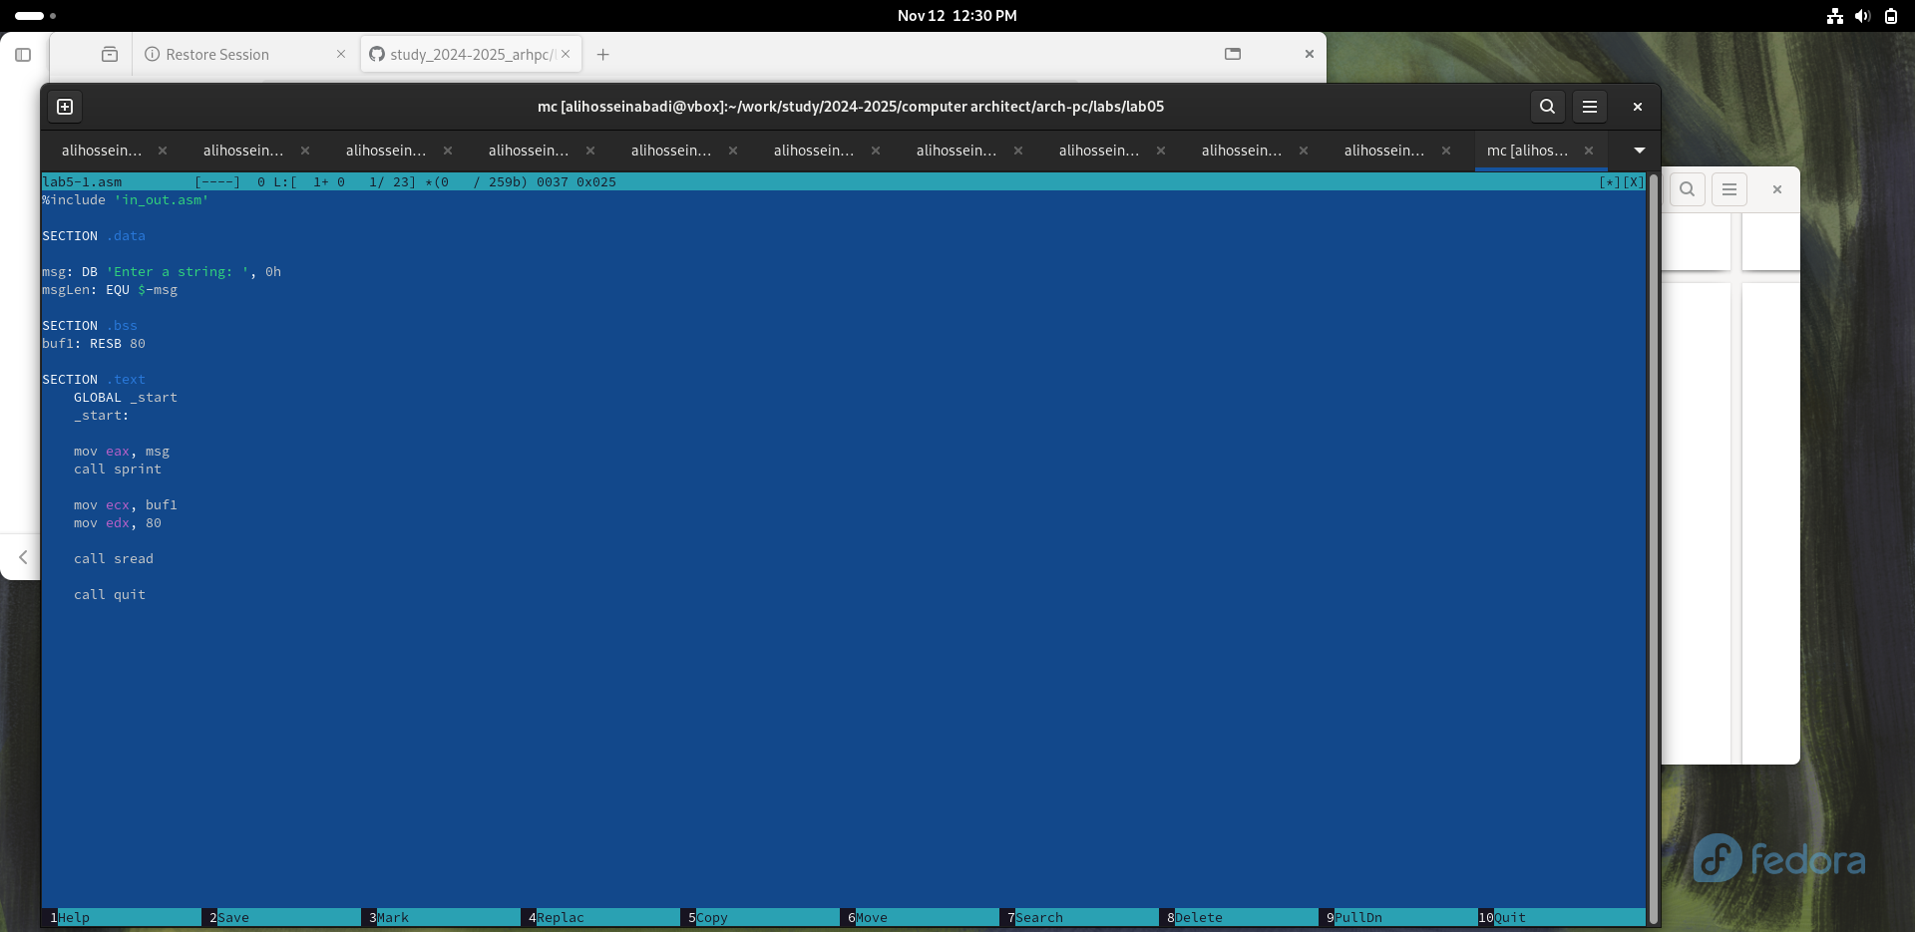

Рис. 10: Changing the Program

I translate, compose, and launch the program with the included file (Figure -fig. 12).

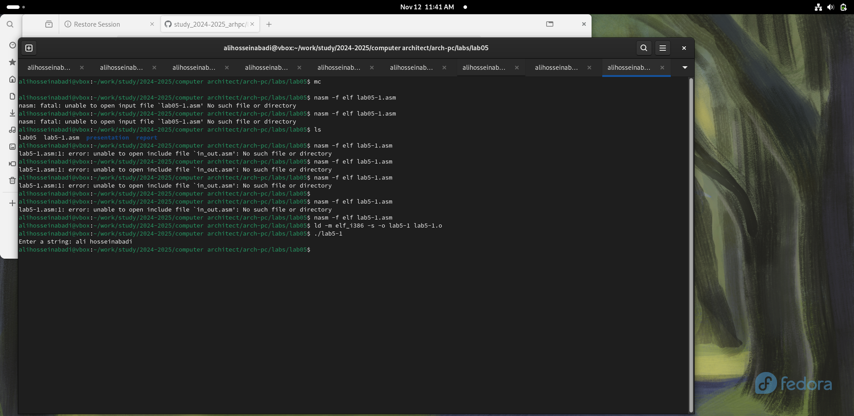

Рис. 11: Launching the Modified Program

I edit the file and replace the sprintLF subroutine with sprint. The difference between the two subroutines is that the second one prompts the input on the same line (Figure -fig. 13).

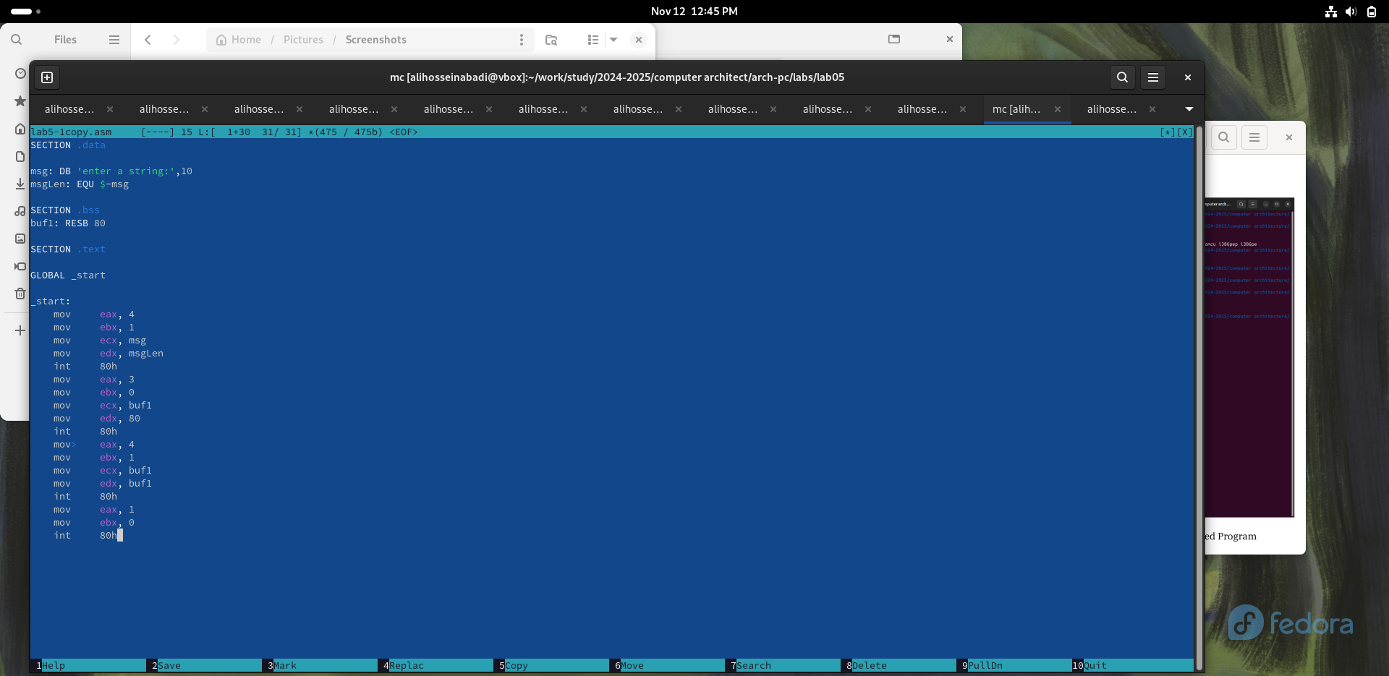

Рис. 12: Running the Modified Program with Different Subroutine

## 3.2 Self-Study Task

I create a copy of lab5-1.asm, editing it so that the string I entered from the keyboard is displayed at the end (Figure -fig. 14).



Рис. 13: Editing the Copy

I translate, compose, and run my program (Figure -fig. 15).



Рис. 14: Running the Program

Here is the code:

SECTION .data  
msg: DB 'write a string:', 10  
msgLen: EQU $-msg  
  
SECTION .bss  
buf1: RESB 80  
  
SECTION .text  
GLOBAL _start  
  
_start:  
 mov eax, 4  
 mov ebx, 1  
 mov ecx, msg  
 mov edx, msgLen  
 int 80h  
  
 mov eax, 3  
 mov ebx, 0  
 mov ecx, buf1  
 mov edx, 80  
 int 80h  
  
 mov eax, 4  
 mov ebx, 1  
 mov ecx, buf1  
 mov edx, buf1  
 int 80h  
  
 mov eax, 1  
 mov ebx, 0  
 int 80h

I create a copy of lab5-2.asm, edit it so that the line I entered from the keyboard is displayed at the end (Fig. -fig. 16).



Рис. 15: Editing a copy

I translate, compose and run my program (Fig. -fig. **¿fig:017?**).



Рис. 16: Running my program

code:

%include 'in_out.asm'  
  
SECTION .data  
  
msg: DB 'write a string: ', 0h  
msgLen: EQU $-msg  
  
SECTION .bss  
buf1: RESB 80  
  
SECTION .text  
 GLOBAL _start  
 _start:  
  
 mov eax, msg  
 call sprint  
  
 mov ecx, buf1  
 mov edx, 80  
  
 call sread  
  
 mov eax, 4  
 mov ebx, 1  
 mov ecx, buf1  
 int 80h  
  
 call quit

# 4 Conclusions

During this lab I gained practical skills in working in Midnight Commander and also mastered the assembly language instructions mov and int.

# References

1. [sample](https://github.com/evdvorkina/study_2022-2023_arh-pc/blob/master/labs/lab06/report/%D0%9B06_%D0%94%D0%B2%D0%BE%D1%80%D0%BA%D0%B8%D0%BD%D0%B0_%D0%BE%D1%82%D1%87%D0%B5%D1%82.md?plain=1)
2. [course on tuis](https://esystem.rudn.ru/course/view.php?id=112)
3. [labrotary work №5](https://esystem.rudn.ru/pluginfile.php/2089085/mod_resource/content/0/%D0%9B%D0%B0%D0%B1%D0%BE%D1%80%D0%B0%D1%82%D0%BE%D1%80%D0%BD%D0%B0%D1%8F%20%D1%80%D0%B0%D0%B1%D0%BE%D1%82%D0%B0%20%E2%84%965.%20%D0%9E%D1%81%D0%BD%D0%BE%D0%B2%D1%8B%20%D1%80%D0%B0%D0%B1%D0%BE%D1%82%D1%8B%20%D1%81%20Midnight%20Commander%20%28%29.%20%D0%A1%D1%82%D1%80%D1%83%D0%BA%D1%82%D1%83%D1%80%D0%B0%20%D0%BF%D1%80%D0%BE%D0%B3%D1%80%D0%B0%D0%BC%D0%BC%D1%8B%20%D0%BD%D0%B0%20%D1%8F%D0%B7%D1%8B%D0%BA%D0%B5%20%D0%B0%D1%81%D1%81%D0%B5%D0%BC%D0%B1%D0%BB%D0%B5%D1%80%D0%B0%20NASM.%20%D0%A1%D0%B8%D1%81%D1%82%D0%B5%D0%BC%D0%BD%D1%8B%D0%B5%20%D0%B2%D1%8B%D0%B7%D0%BE%D0%B2%D1%8B%20%D0%B2%20%D0%9E%D0%A1%20GNU%20Linux.pdf)
4. [prograaming in nasmlanguage](https://esystem.rudn.ru/pluginfile.php/2088953/mod_resource/content/2/%D0%A1%D1%82%D0%BE%D0%BB%D1%8F%D1%80%D0%BE%D0%B2%20%D0%90.%20%D0%92.%20-%20%D0%9F%D1%80%D0%BE%D0%B3%D1%80%D0%B0%D0%BC%D0%BC%D0%B8%D1%80%D0%BE%D0%B2%D0%B0%D0%BD%D0%B8%D0%B5%20%D0%BD%D0%B0%20%D1%8F%D0%B7%D1%8B%D0%BA%D0%B5%20%D0%B0%D1%81%D1%81%D0%B5%D0%BC%D0%B1%D0%BB%D0%B5%D1%80%D0%B0%20NASM%20%D0%B4%D0%BB%D1%8F%20%D0%9E%D0%A1%20Unix.pdf)